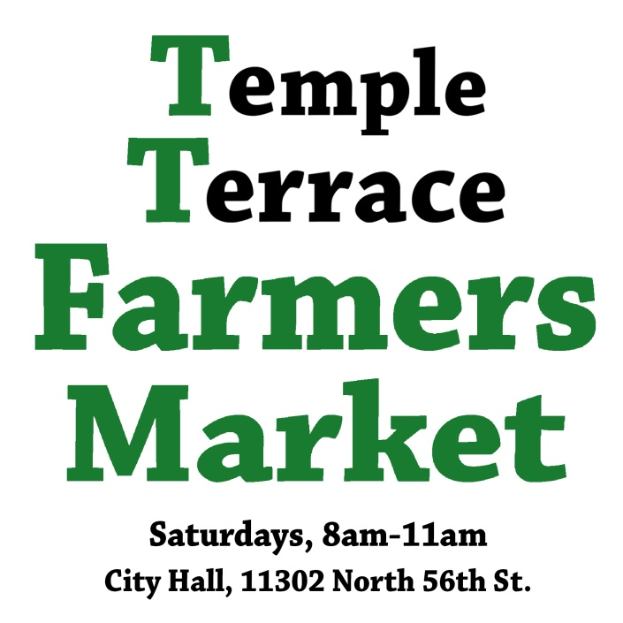

MARKET RULES & REGULATIONS

Temple Terrace Farmers Market
Market Duration: Year round
Market Location: 11302 N. 56th St., Temple Terrace, between City Hall and Outback Steakhouse
Time: Saturday 8am – 11am. Vendors may begin setting up at 6:30am.

ABOUT: The Temple Terrace Farmers Market is farmer-run. Travis Malloy from TrailBale Farm organizes and manages the market. Vendor preference is given to local producers, following organic practices. Vendors distributing local products will be accepted if no local producers are available for the market. Once a local producer is available, they will be given preference. Given limited space, agriculture vendors will be given preference over non-agriculture vendors.
MARKET SETUP: Upon acceptance to the market, you will be assigned a 10’ x 10’ booth space. Vendors are not allowed to use more than their allotted booth space without approval. This includes placing signage in aisles and displays outside your 10’ x 10’ area. Farmers market staff and volunteers have the right to ask for signage/displays to be rearranged if they are blocking another vendor or customer traffic flow. Vendor parking is available in the market parking lot (towards the rear) or in the City Hall parking lot. Vendors are permitted to setup beginning at 6:30am. Vendors must be set up, with vehicles out of the market area, by 7:50am. At market closing, vehicles won’t be let into the market area until 11:10am, to allow for last-minute shopping.
Restrooms are not available at the market location. The nearest public restrooms are at Burger King and Publix, both at the corner of 53rd St and Fowler Ave, 1000 feet from the market via the parking lot rear entrance on 53rd St. It’s a short drive and a long walk.
FEES: Farmers, beekeepers, ranchers, agriculture producers: Free.
All other vendors: $15/week.
Payments due the day of market. Market manager will collect by the end of the market.
EQUIPMENT: The vendor must provide all necessary equipment and displays. The market will not provide extension cords, signs, chairs, tables, tablecloths, scales, display containers, tents or weights. All materials, including table, tents, chairs, and signage must fit within the vendors’ assigned 10’ x 10’ space. For your safety and for the safety of those around you, all canopies, tents, umbrellas and all other forms of booth covering should be securely anchored at every market from the moment the canopy is erected until the moment immediately before the canopy is taken down. We recommend 25 lbs of weight for each tent leg. Vendors whose tents or umbrellas lift off the ground will be asked to take down their canopy. Vendors are strongly encouraged to use signage at their booth listing the name of their business and their contact information. Each vendor is responsible for maintaining his/her area in a clean, neat manner throughout the market and cleaning the area before departing. Vendors should plan to take large trash with them, as dumpster and trash can access is limited. Access to electricity is difficult, but can be made available with advanced notice. If you need electricity, indicate this on the application.
PRODUCT GUIDELINES: The market is primarily a producer’s market, meaning products are grown, produced or prepared by the vendor. The market supports local and sustainable products. Vendors must clearly post prices on all products being sold. Vendors are responsible for all their own applicable sales tax. Pricing of goods sold is the sole responsibility of the vendor. It is the vendor’s sole responsibility to carry the appropriate license with the Division of Plant Industry and the Florida Department of Agriculture. Proper licensing to run a business is the sole responsibility of the participating market vendor.
VENDOR CONDUCT: Vendors should abide by all city, county, state and federal regulations that govern sampling, production, labeling, and safety of every product offered for sale at market. This includes responsibility for certifying and annually calibrating any scales. Vendors are responsible for carrying liability insurance minimum $1M limits which names Temple Terrace Farmers Market, Inc. as an additional insured. The Temple Terrace Farmers Market carries event liability insurance for the market, but does not cover individual vendors or their products. Vendors assume all responsibility for any losses of property or money from the market site. Booths should never be left unattended. If you see suspicious activity, please contact the market manager or staff. No commercially manufactured candy or other foods should be given away at booths. In the interest of the health and cleanliness of the market, smoking and the use of tobacco products is not allowed in or around vendor stalls. Professional conduct is expected. Any yelling, swearing or threatening customers, vendors or staff will not be tolerated. This includes in person or by electronic media. This type of behavior will result in expulsion from the market.
MARKETING: The market exclusively determines the content and focus of any print, internet or broadcast marketing material. The market is attempting to create a cohesive brand for this unique event. Vendors are encouraged to advertise their farms, companies, etc, and promote their participation in the market. Vendors are not allowed to represent, speak for or directly advertise the Temple Terrace Farmers Market without permission from the market manager.
WEATHER: The market will be held through most foul weather. If the forecast predicts weather too bad for a market, we’ll contact vendors the evening before the market. Feel free to call Travis at 786-842-7909 for a weather check or come on down and wait it out with us.
SCHEDULING: We would prefer that all vendors attend the market every week. If this is not possible, send your monthly schedule two weeks in advance, so that we can advertise properly and adjust for product coverage.
CANCELLATIONS: As stated above, the market is held rain or shine. Cancellations for a reserved market must be made ONE WEEK in advance of the market to request a refund. Temple Terrace Farmers Market understands that emergencies do happen and will be considerate to any of these last minute cancellations.
TRANSIENTS & SOLICITATION: While we feel the location of the market is a safe one, please use good judgement when setting up and breaking down or if you decide to leave your stall for anytime. Have a neighboring vendor watch your belongings while you park your vehicle if setting up alone.
SOLICITATION: Advertising for other events or businesses during the market is not allowed without prior approval from Temple Terrace Farmers Market staff. This includes anyone not associated with the market passing out flyers to vendors/customers. Please alert Temple Terrace Farmers Market staff to any violations of this policy.
COMPLAINTS: All complaints must be submitted in writing or email, and given to Travis Malloy. Unsigned complaints will not be addressed. Complaints should be specific in nature. Allegations of resale will be taken seriously and investigated through business/farm inspections and questions regarding the manner in which a product is produced.
INFRACTION POLICY: Any vendor found in violation of the market’s Rules and Regulations, as stated above, which includes but is not limited to: No-shows, no/insufficient canopy weights, selling unauthorized products, unapproved or improper product sampling, market marketing, etc. will be subject to the following disciplinary process: 1st violation – Oral notification from Temple Terrace Farmers Market staff. 2nd violation – Written notification from Temple Terrace Farmers Market staff. 3rd violation – Expulsion from the market.
Enforcement of these Rules and Regulations is the responsibility of the Market Manager and his/her staff and volunteers. Vendors should report any suspected offenses to the Market Manager, Travis Malloy, trailbalefarm@gmail.com. 786-842-7909 cell.

APPLICATION
Applicant Name: _________________________________________________________________
Company Name: _________________________________________________________________
Cell Phone Number: _________________________________________________________________
E-mail Address: _________________________________________________________________
Website: _________________________________________________________________
Preferred mode of communication for important information (market cancellations, etc)?
- Phone call
- Text message
- Email
Which category best fits your product offering?
- Agriculture: Produce, meats, eggs, plants, honey, farm products
- Agriculture-complementary products: spices, jellies
- Take home foods, packaged foods
- Soap
- Ready to eat foods
- Hand crafts
Will you set up with a canopy tent?
- Yes, I prefer to
- I have one, but I prefer not to
- No
Do you need electricity to operate your booth space?
- Yes, I absolutely need it
- No
If you are a food vendor please check one of the options below:
Do you meet the requirements of the Department of Agriculture and the Division of Hotels and Restaurants?
- Yes and I meet all the requirements.
- No, and I do not have what is needed.
- This does not apply to me.
Please provide the license number for your food vendor permit:
____________________________________________________
Please give a detailed description of what you want to sell: ___________________________________________________________________________________________________________________________________________________________________________________________________________________________________________________________________________________________________________________________________________________________________________________________________________________________________________________________________________________________________________________________________________________________________________________________________________________
Please list your schedule preference. We are a weekly market, and weekly vendors are preferred.
Preferred Start Date: _______________________________
Frequency: weekly, bi-weekly, monthly, other:

Specific dates you cannot attend: _______________________________________________________________________________________________________________________________________________________________________________________________________________________________________________________________

